FUNDAMENTALS :
1.PROGRAM
Definition
A program is a set of instructions given to a computer to perform a specific task.
Example
A program that adds two numbers and prints the result.
Real-life Example
A cooking recipe.
If you miss a step (like adding salt), the dish still runs… but tastes terrible.
Real-world Example
Calculator app, alarm app, payroll software.

2. Programming
Definition
Programming is the process of writing instructions that tell a computer what to do and how to do it.
Example
Writing logic to check if a user is valid before allowing login.
Real-life - Example
Giving directions to a friend who takes everything literally:
“Turn left”
Friend: falls into a lake because you didn’t say ‘on the road’
That’s programming without clarity.
Real-world Example
Writing backend logic for food delivery, banking systems, automation tools.

3. Programming Language
Definition
A programming language is a language used to write programs so that computers can understand and execute tasks.
Example
Java, C, C++, C#
Real-life - Example
Talking to different people:
- English -> office colleague
- Native Language -> family
- Programming language -> computer
Speak wrong language -> zero response.
Real-world Example
- Java -> banking systems
- C -> operating systems
- C++ -> game engines

4. Scripting Language
Definition
A scripting language is a type of programming language mainly used to automate tasks and uses interpreter to execute its code.
Example
JavaScript, Python, Shell Script
Real-life Example
You don’t build a car every day.
You just drive it.
Scripting languages drive existing systems, they don’t build engines from scratch.
Real-world Example
- JavaScript → browser interaction
- Python → automation, data processing
- Shell → server maintenance scripts

5. Compiler
Definition
A compiler will execute all the code at once.
Example
C program compiled using gcc.

6. Interpreter
Definition
Interpreter will execute the code line by line.

7. Programming Language vs Scripting Language
Programming Language | Scripting Language
Used to build systems | Used to automate or control
Often compiled | Often interpreted
Suitable for large systems | Suitable for quick tasks
Examples: Java, C++ | Examples: JS, Python
Summary
Programming language = building the restaurant
Scripting language = taking orders inside it

8. JavaScript
Definition
JavaScript is a scripting language used to add dynamic behavior to applications.
Example
Button click → show popup.
Real-life - Example
HTML is the body
CSS is the clothes
JavaScript is the brain
Good clothes without brain = mannequin.
Real-world Example
- Form validation
- Live updates
- Web applications

9. Application Architecture (3-Tier)
Definition
Applications are divided into layers so responsibilities are clean and manageable.
Example
Frontend → Backend → Database
Real-life - Example
Customer → Waiter → Kitchen
Customer never enters kitchen directly.
Real-world Example
- Frontend: UI (React, HTML)
- Backend: Business logic (Java, Node)
- Database: Data storage (MySQL, MongoDB)
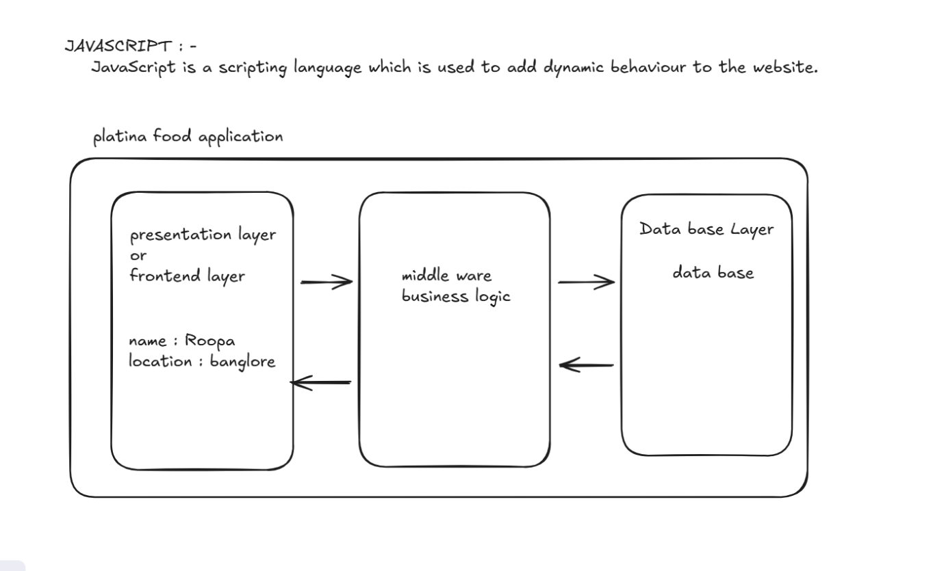
Presentation Tier
Definition
The Presentation Tier is the layer that the user can see and interact with.
Its only job is to take input from the user and show output.

Real-life example
You go to a restaurant.
- You read the menu
- You tell the waiter your order
You do NOT enter the kitchen or cook the food.
You = user
Menu & waiter interaction = Presentation Tier
Real-world example
- Browser UI (HTML, CSS, JavaScript, React)
- Mobile app screens
This layer collects data and displays results, nothing else.

Middleware / Business Logic
Definition
The Application Tier is the brain of the application.
It decides what should happen based on rules and logic.
Real-life example
In the restaurant:
The chef decides:
- Is the order valid?
- How to prepare it?
- What ingredients to use?
Chef = Application Tier
All decisions happen here
Real-world example
- Java Spring Boot
- Node.js (Express)
- Python (Django / Flask)
This layer:
- Validates input
- Applies business rules
- Communicates with the database

Database Layer
Definition
The Data Tier is the layer where data is stored permanently and retrieved when needed.
Real-life example
In the restaurant:
The store room where ingredients are kept:
- Rice
- Vegetables
- Spices
Store room = Data Tier
It does not cook, it just stores.
Real-world example
- MySQL
- PostgreSQL
- MongoDB
This layer:
- Stores data
- Returns data
- Enforces constraints
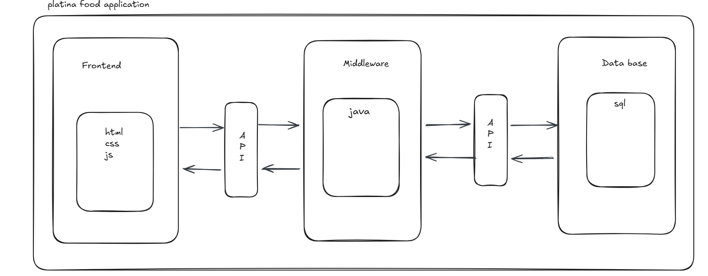

API (Application Programming Interface)
Definition :
An API is a middleman that allows two applications to talk to each other in a controlled and secure way.
One application requests data
Another application responds with data
API defines how this communication should happen
Real-life example
Think of a restaurant waiter.
- You (customer) don’t go into the kitchen
- You tell the waiter what you want
- The waiter takes the request to the kitchen
- The waiter brings back the food
You = Client
Kitchen = Server
Waiter = API
You never see how food is cooked.
You only know what to ask and what you’ll get back.
Real-world example
- Frontend (React / Browser) sends a request
- Backend (Java / Node) exposes an API
- API returns data in JSON format
Example:
- Login API
- Get user details API
- Payment API
Frontend never talks directly to database
It always talks through API
IMPORTANT CLARITY
- API is not a language
- API is not a database
- API is not the backend itself
- API will not convert one programming language into other language it will just let two languages communicate with each other.
API is a contract:
- What request to send
- What response you’ll receive

Why JavaScript is used for Playwright ?
Playwright is built on Node.js, and Node.js runs JavaScript.
So when we write Playwright tests in JavaScript, the code can directly talk to Playwright.
When we use other languages, the code must go through an API layer to communicate with Playwright.

Real-life example
Think of a manager and employee:
- Manager speaks the same language as the employee → direct conversation
- Manager speaks a different language → needs a translator
JavaScript = same language
Other languages = translator
Translator = API layer
JavaScript doesn’t need a translator.
Real-world example
JavaScript Test Code
↓
Playwright (Node.js)
↓
Browser
- No API layer in between
- Faster and simpler
Using JAVA / PYTHON / C#
Test Code (Java / Python / C#)
↓
Language Binding
↓
API Communication
↓
Playwright (Node.js)
↓
Browser
- Extra API layer
- Serialization / deserialization
- More overhead

WHAT IS JAVASCRIPT?
Definition
- javascript is a scripting language which uses interpreter to execute its code.
- Javascript is scripting language which is readable, analyzable and executable by browser itself.
- javaScript is used to add dynamic behaviour to my webpage or website
Real-world example
- Showing a popup message
- Validating a login form
- Updating content without reloading the page
- Counter app (increase / decrease value)
All these behaviors are handled using JavaScript.
Real-life example
A TV remote:
- TV screen is visible (HTML)
- TV looks good (CSS)
- Remote controls actions like volume and channel (JavaScript)
Without the remote, the TV is useless.

FEATURES OF JAVASCRIPT :
Definition
Features of JavaScript are the special qualities that make JavaScript easy to use, fast, and powerful for building web applications.
FEATURES :
- Dynamically typed
- Loosly typed
- Client-side and server-side scripting
- Synchronous
- Single threaded
- High level language
- Scripting language.
1.Dynamically Typed
Definition
Dynamically typed means we do not need to declare the data type of a variable.
JavaScript decides the type at runtime based on the value.
Real-world example
let x = 10;
x = "hello";
x = true;
Real-life example
A water bottle:
- Morning → water
- Afternoon → juice
- Evening → tea
Same bottle, different contents.
2. Loosely Typed
Definition
In JavaScript we will not restrict that a variable should hold only a specific value, that makes my javascript a loosely typed.
Loosely typed means JavaScript automatically converts data types when required instead of throwing errors.
Real-world example
let a;
let a=10
let a=true;
console.log(5 + "5"); // "55"
JavaScript converts number to string automatically.

Real-life example
Talking to a friend:
- You say “5 minutes”
- They understand time, not the number
- We don’t have any restriction that we should speak only one language, we can speak any language.
3. Client-side and Server-side Scripting
Definition
JavaScript can run inside the browser (client-side) and also on the server.
Real-world example
- Client-side:
  - Form validation
  - Button click handling
- Server-side:
  - APIs
  - Database interaction (using Node.js)
Real-life example
A delivery app:
- App screen → user interaction (client-side)
- Warehouse → order processing (server-side)
Same company, different responsibilities.
Synchronous
Definition
Synchronous means JavaScript executes code line by line / sequence, one step at a time.
Real-world example
console.log("A");
console.log("B");
console.log("C");
Output will always be:
A
B
C
Real-life example
Standing in a queue:
- First person finishes
- Then second
- Then third
No skipping.
5. Single Threaded
Definition
Single threaded means JavaScript can execute only one task at a time on the main thread.
Real-world example
If JavaScript is executing a loop, it cannot handle another task at the same time on that thread.
Real-life example
A single teacher in a class:
- Can answer only one student at a time
- Others must wait
JavaScript works the same way.
6.High-Level Language
Definition
A high-level language is easy for humans to read and write, and it hides hardware-level details.
Real-world example
let sum = a + b;( a human can read easily )
You don’t worry about memory, registers, or CPU instructions.
Real-life example
Driving a car:
- You use steering, brake, accelerator
- You don’t think about engine pistons or fuel injection
JavaScript handles complexity internally.

7.Scripting Language
Definition
A scripting language executes code using interpreter and is mainly used to control or automate behavior.
Real-world example
JavaScript:
- Controls web page behavior
- Responds to user actions
- Works with APIs
No manual compilation step like traditional languages.
Real-life example
A remote control:
- Press button → action happens immediately
- No setup or build process
JavaScript reacts instantly.

DIFFERENCE BETWEEN JAVA AND JAVASCRIPT :
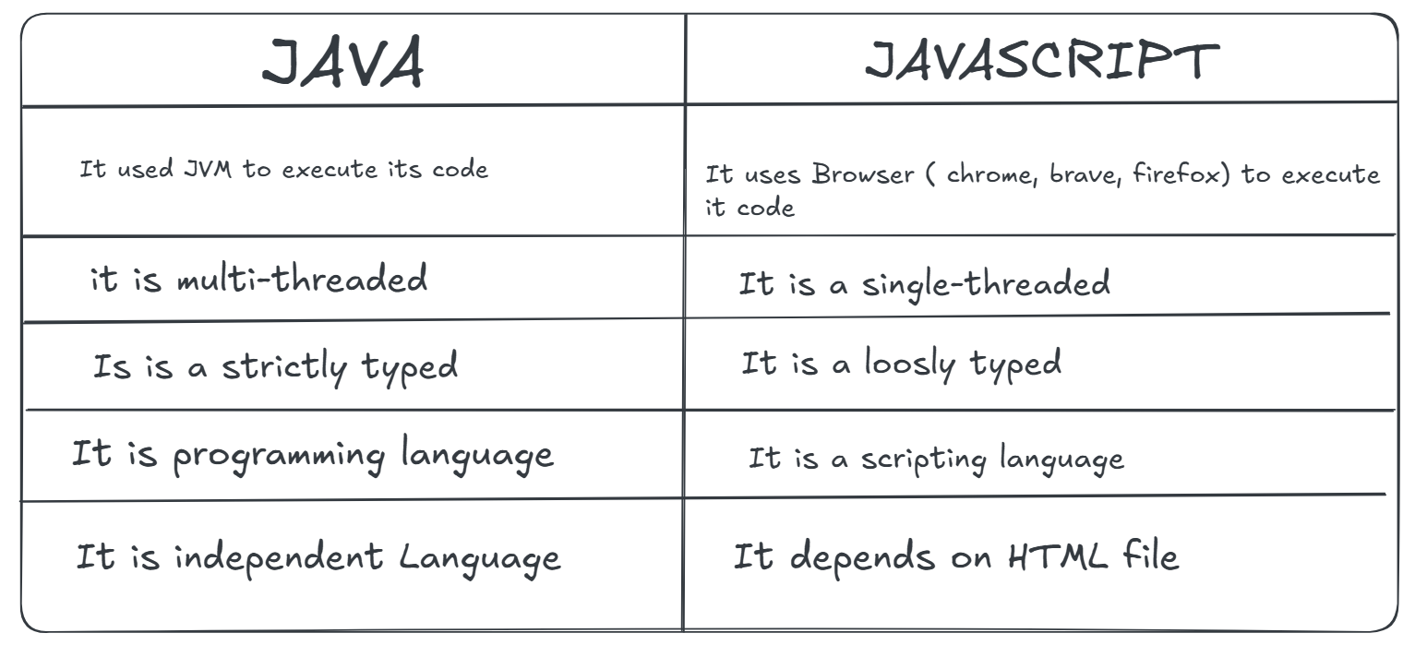

HISTORY OF JAVASCRIPT
The first popular web browser with a graphical user interface, Mosaic was released in 1993.
❖ The lead developers of mosaic then founded the Netscape Corporation, which released more polished browser, Netscape Navigator, in 1994.
❖ At that time webpages are only static.
❖ In 1995, Netscape corporation people decided to add a programming language to their Netscape navigator to bring the functionality to the webpages.
❖ So, they wanted to embed java as a core language to bring the functionality, but Sun microsystems did not accept their proposal.
❖ So, they hired Brenden Eich who was working with Scheme language at that time.
❖ So, in the same year i.e. 1995 Brenden Eich designed our JavaScript, and he named it as Mocha, to design he took only 10 days.
❖ After Netscape corporation people changed the name as live Script, but it was not become that much popular, so they changed the name to JavaScript, because java was booming at that time.
❖ In the same year 1995, Microsoft released Internet Explorer along with Jscript which is same as JavaScript only.
❖ In the year 1996 Netscape corporation submitted JavaScript to ECMA (European Computer Manufacturing Association) to create standards to JavaScript.
❖ In 1997 ECMA released standardized JavaScript version which officially called as ECMAScript1
❖ In ECMAScript 6 version we got major updates like let, const, Rest parameter, Spread Operator, fetch Api, Arrow function etc.
❖ So, they decided to add new features in every year in the month of June.
❖ Now currently the JavaScript version is 15 that is officially ECMAScript 15.

Ways to execute java script file:
- We can execute JS by embedding in the html page.
a. Internal way
With the help of <script> tag we can embedded the java script code.
We won’t use script tag in head section as when executing the html file initially head will
execute along with it js code also get executes which may cause some errors.
b. External way of adding a JavaScript:
- we can create a separate file for JavaScript code with extension .js.
- Link the js file with html page using src attribute inside the opening of script tag.
TOKENS IN JAVASCRIPT :
Tokens are smallest units of any programming language.
1. Keywords :
keywords are the predefined words which are having some special meaning or special purpose. Keywords are always in lower case
Ex: var, let, const, if, else, break, continue, switch, for, while, function, async.
2. Identifiers :
Identifiers in JavaScript are names given to variables, functions, properties, and other entities in code.
Rules to give identifiers:
- They can contain alphabets, digits and some special characters.
- They may contain digits but cannot starts with digit.
- Except dollar ($) and underscore (_) other special characters are not allowed.
- Reserved words (keywords) in JavaScript cannot be used as identifiers.
3. Comments:
Comments are the line of code that are not executed by the browser.
Comments are used to add the notes, description and explanation about the JS code.
JavaScript support 2 types of comments.
1. Inline comment (//)
2. Multi line comment (/* */)
4. Literals:
Literal is nothing but the data provided by the user.
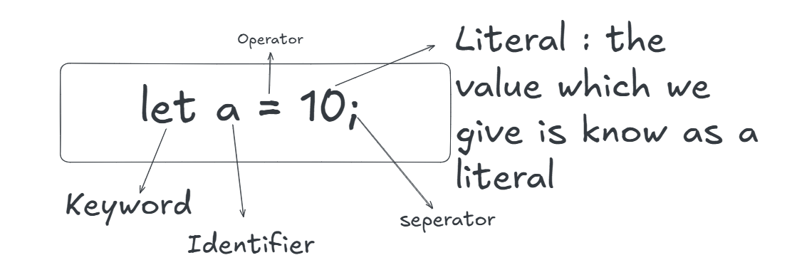
5.Seperators :
Separators are used to differentiate the statements written in a JavaScript file.
Ex: semi-colon, single quotes, double quotes, comma.
Variables in JavaScript :
Variables are nothing but the container to store your data.
In JavaScript create variable in three ways :
- Var
- Let
- Const
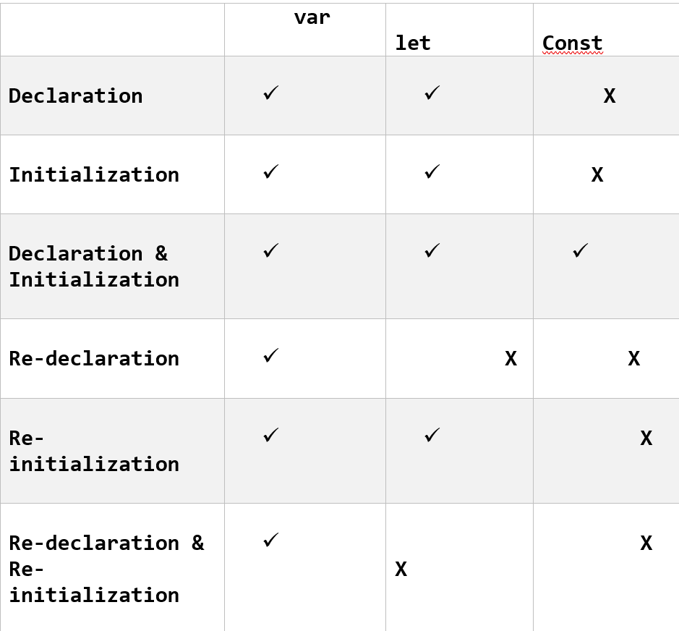

HOISTING :
Hoisting in JavaScript is a behaviour where variable and function declarations are moved to the top of their scope before code execution.
- This allows you to use variables and functions before they are declared in the code.
- It is a processing of accessing the variables before its declaration this will be possible with variables declared with var, let and const.
- If we try to access var variables before declaration we can get undefined as output as because var variables are global members.
- If we try to access let and const variables before their declaration we can get reference error as because let and const variables cannot be used until it has been declared because those variables in a temporal dead zone (TDZ).
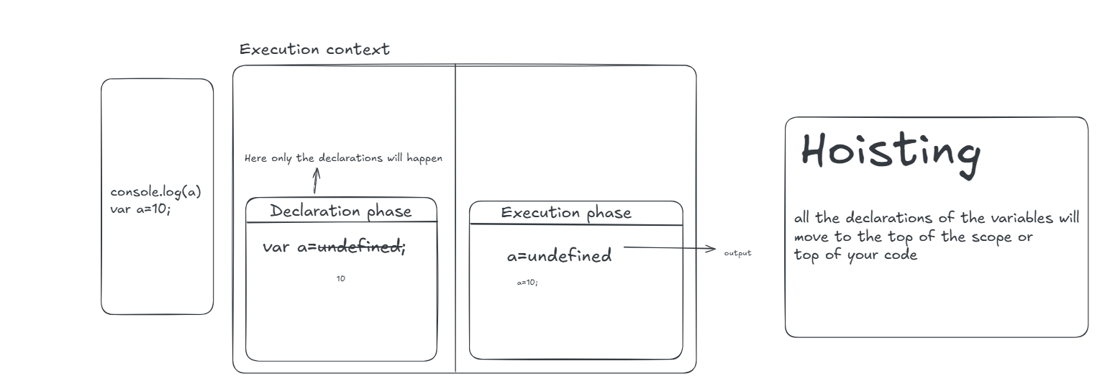
TEMPORAL DEAD ZONE ( TDZ ) :
- It is a period between when a variable is declared and before it is initialized with the value.
- During this time the variables is inaccessible and if we try to access it throws and error.
- It will effects variables declared with let and const keywords.
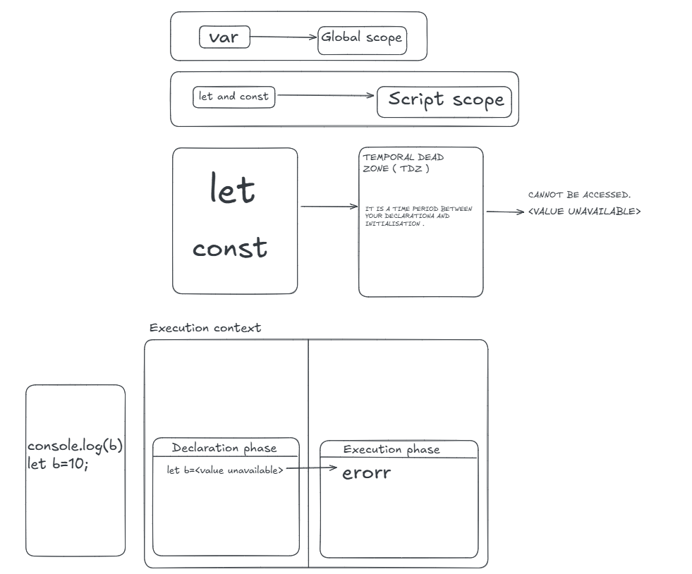
Example :
/console.log(a);//Reference Error
let a;//variable declaration
a = 10;//variable initialization
let b = 20;//variable declaration + initialization
console.log(a);//10
console.log(b);//20
With Var keyword:
- Var is the traditional way of declaring the variables.
- The scope of the var variables is global scope and functional scope.
- It can be redeclare and updated within its scope.
- It can be declared without initialization.
- It can be accessed without initialization as its default value as undefined.
- These variables are hoisted. [whenever we are trying to access the value be before declaration or initialization that process is known as hoisting where it shows undefined.]
With Let keyword:
• The scope of let variable is the Script scope or block scope.
• It can be declared without initialization.
• It can be reinitialized but cannot be redeclared in the same scope.
• It cannot be accessed before declaration and initialization.
• If we try to hoist (access before declaration) we will get Reference Error.
• If you are trying to access after the declaration without initialization, we will get value as the undefined.
With const keyword:
• The scope of the const variable is Script scope and block scope.
• It can neither be reinitialized nor redeclared in any scope.
• It cannot be declared without an initialization.
• It cannot be accessed without initialization
• If we try hoist (access before declaration) will get Reference Error.
OPERATORS:
Operators in JavaScript are symbols that perform operations on values (operands). These operations can be arithmetic, logical, assignment, comparison, bitwise, or string based.

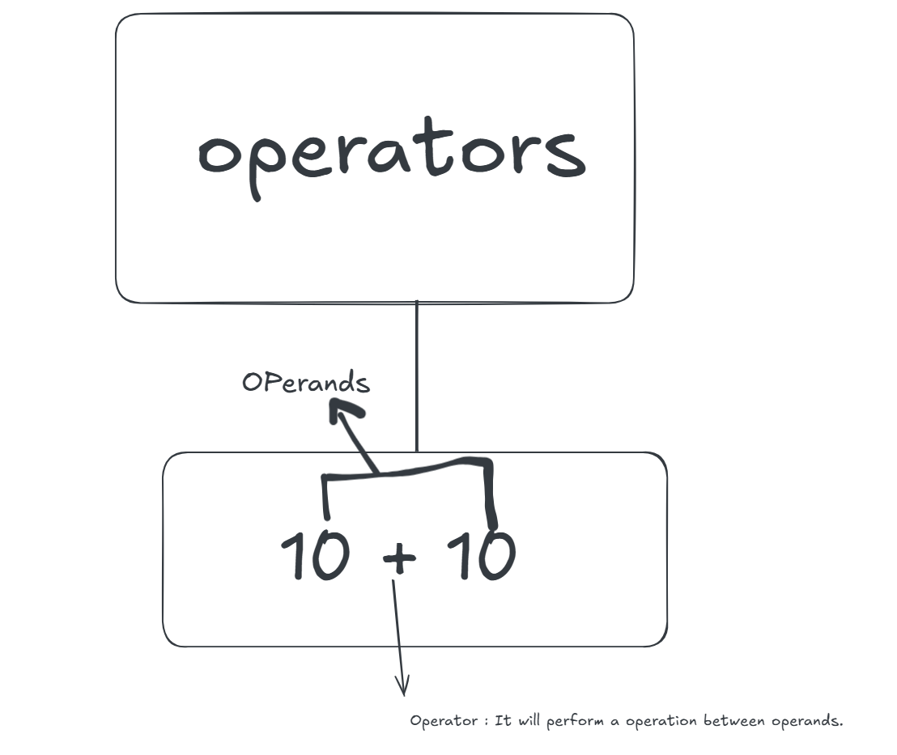

Types of Operators :
- Arithmetic Operators
- Assignment Operators
- Relations Operators
- Logical Operators.
- Ternary Operator
Arithmetic Operators
Used for mathematical calculations.
Types of Arithmetic Operators :
- Additon (+): Used to add the number
- Subtraction (-): Used for subtraction
- Multiplication(*): Used for multiplication
- Division(/): Used for division and we will get the quotient
- Modules(%): Used for division but we will get reminder
- Exponentiation(**): Used to get the exponential values.
- Increment and decrement :-
- Post increment and decrement
First use the value and the increase or decrease it
Example :-
let a = 10;
// console.log(a); //10
// a++; // 11
// console.log(a);

- Pre increment and decrement
First do the operation and the use the incremented or decremented value.
let a = 10;
console.log(++a);//11

COMPARISON OPERATORS: Used to compare values.
- == ( Equality Operator )
- != ( Not equal operator )
- > ( Greater than )
- < ( less than )
- >= ( greater than or equal )
- <= ( less than or equal )

ASSIGNMENT OPERATOR :
To assign a value we will use assignment operator.
We will use “ = “ to assign a value.
LOGICAL OPERATORS:
Used to combine multiple conditions.
Types of Logical Operators
- && (Logical AND)
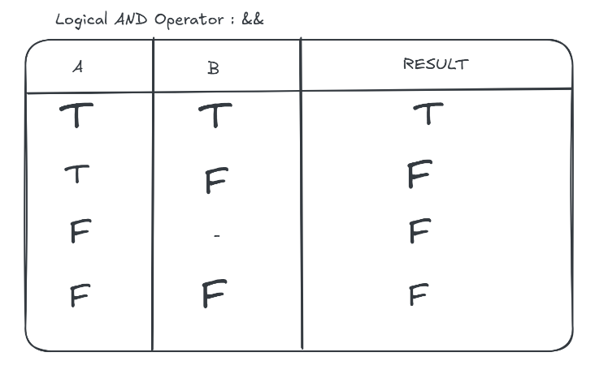

- || (Logical OR)
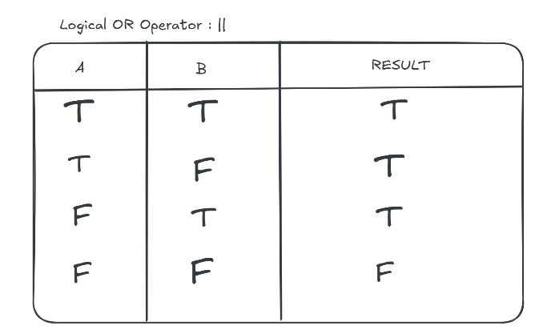

- ! (Logical NOT)
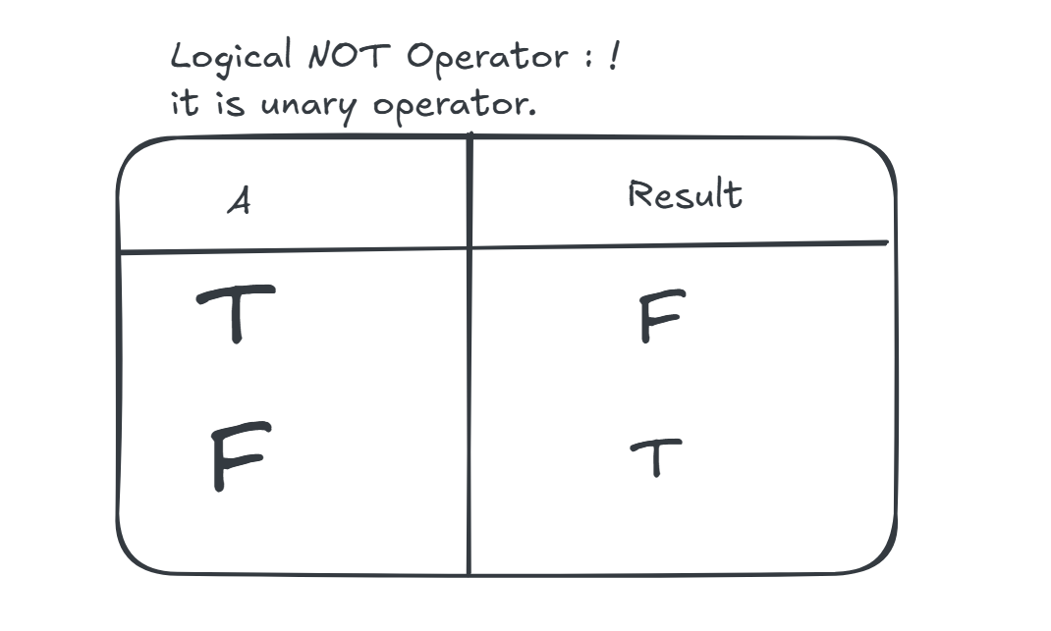
TERNARY OPERATOR:
A shorthand for an if...else statement.
Syntax : condition? exprIfTrue : exprIfFalse
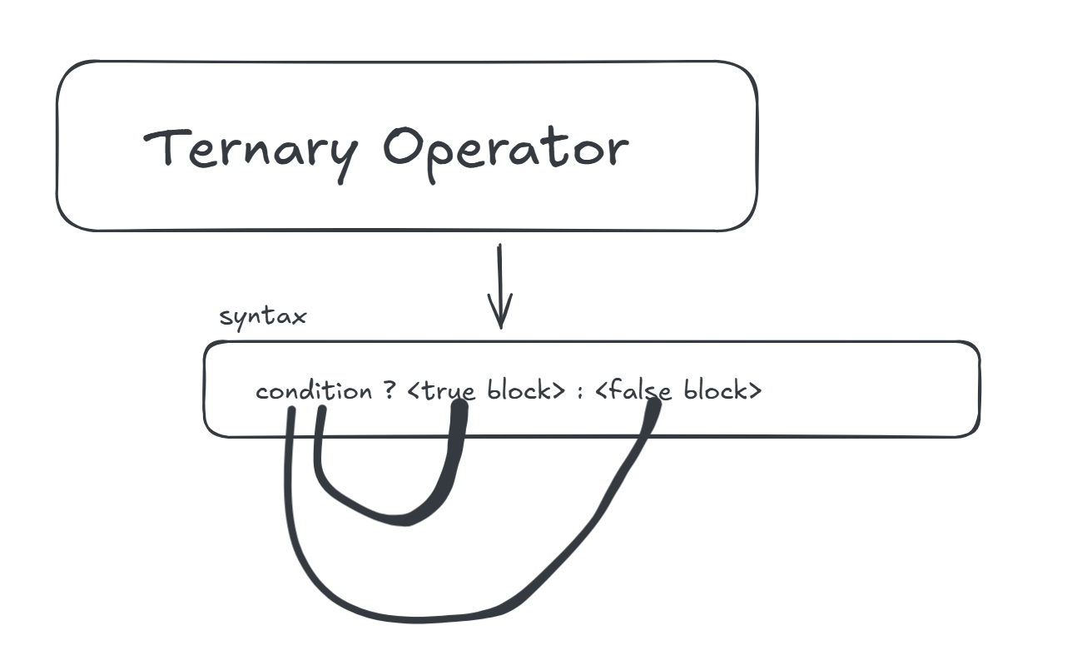
Unary Operator :
An Operator which uses a single operand is know as unary operator.
Example : a++, !(a) etc..
Binary Operator :
An Operator which uses two operands to perform an operation is known as Binary operator.
Example : a+b, c+d
Ternary Operator :
An operator which uses three operands to perform an operation is known as Ternary Operator.
Example : a+b =10 ? “the a is greate” : “the b is greater”.
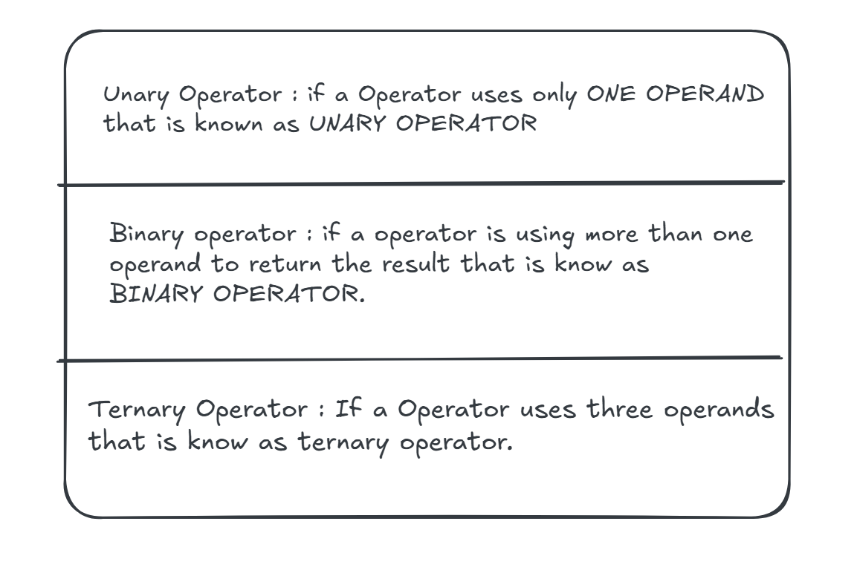

Data Types :
- Data types are used to define what type of data we are going to store in a particular variable.
  - Data types are used to specify which type of value a variable can hold.
  - They define the kind of data present inside the variable.
  - JavaScript provides different data types to store the different types of values.
Types of Data Types :
- Primitive Data types
- Non-primitive data types

1.Primitvie Data Types :
The primitive datatypes are single value data and primitive values are immutable.
Types of Primitive Data Types :
- Boolean
- String
- Number
- Undefined
- Symbol
- Null
Number:
➢ Number datatype can use decimal as well as non-decimal values.
Ex: var a = 10;
Boolean:
1. Java script Boolean represent true or false values
2. It is used for logical operations, conditional testing and variable assignments based on conditions.
Undefined:
- This means that a variable has been declare but has not been assigned a value or it has been explicitly set to the value undefined.
Let a = undefined
Console.log(a); //undefined
Null:
1. Null is an empty value.
2. Null is not same as the zero.
3. Null is the absence of any value.
String :
The collections of characters is known as a String.
Ex : var a=”hello world”
Symbol :
It is used to give the unique values.
Ex: var a =Symbol(“hello”);

Typeof :
This is used to get to know what type of data is stored inside the variale.
Example :
Var a=10;
Console.log(typeof a);

Decision Making Statements/Conditional Statements :
Conditional statements allow us to represent decision making in java script, from the choice that must be made.
Types of conditional statements:
1.if
2.if-else
3.else-if ladder
4.nested if
5.switch
1) If:
It is used for some statement has to be executed based on the single condition.
Syntax:
if(condition)
{ //statements }
Ex:
let cookiesAvaliable=1
if (cookiesAvaliable == 1) {
Console.log (“I will eat one cookie”);
}
2.) If else statement
• It is use when some set of code has to be executed based on some condition otherwise, some other set of code is executed.
• If statement tells us that if a condition is true, it will execute a block of a statement and if the condition is false else block get executed.
Syntax:

If(condition) {
//statements
} Else {
//statements
}
Example:
If(isGraduated) {
Console.log (“You are eligible to apply to this job”);
} else {
Console.log (“You are not eligible to apply to this job”);
}

3.) Else if ladder:
• It is used when some set of statements has to be executed based on hierarchical conditions
• If none of the conditions is true, then the final else block gets executed.
Syntax:
If(condition1){
//statements
} else if(condition2) {
//statements
} else {
//statements
}
Example:
if (marks > 90) {
console.log(“Excellent keep it up”);
} else if (marks70) {
console.log(“Very good keep growing”);
} else {
console.log (“good score work hard to get better marks”);
}
4.) Switch Statement:
• It is used when multiple conditions have to be evaluated based on single variable expression.
• The switch statement evaluates an expression matching the switch value against the series of cases values and execute the statement after the first case matching value util a break statement is encountered.
• The default case of switch statement will be jump to if no case matches with the switch value Syntax:
switch(expression) {
case value1:
//statements
break;
case value2:
//statements
break;
default:
//statements
}
Example:
switch(time) {
case “morning”:
console.log(“Good Morning !! have a nice day”);
break;
case “afternoon”:
console.log (“Very Good Afternoon !! ”);
break;
case “evening”:
console.log (“Good Evening”);
break;
case “night”:
console.log (“Good Night!! Sweat Dreams”);
break;
default:
console.log (“Have a nice day”);
}
LOOPING STATEMENTS:
Whenever we want to perform a task repeatedly that time we can go with the looping statement. There are different types of looping statement in JavaScript.
1.) for loop
2.) while loop
3.) do while loop
1) FOR LOOP:
for loop it is used to execute set of statements repeatedly.
It is commonly used when we know how many times the loop needs to be executed. Syntax:
for (initialization; condition; updation) {
//set of statements
}

2) While loop:
• It loops through a block of code as long as specified condition is true.
• It commonly used when you don’t know how many times you want to execute a block of code and it is based on the condition.
Syntax:
Initialization
While(condition) {
//statements 17 //
updation
}
3) Do while loop:
• Do while loop will execute code of block once before checking the condition.
• If the condition is true then it will repeat the loop as long as the condition is true, and once condition is false it will stop the execution of the block
• It is commonly used when you have to execute the loop at least once.
Syntax:
Initialization
do {
//statements //updation
} while(condition);

FUNCTIONS IN JAVASCRIPT
Functions are one of the fundamental building blocks in JavaScript.
• Functions in JavaScript are reusable blocks of code designed to perform specific tasks.
They allow you to organize, reuse, and modularize code. It can take inputs, perform actions, and return outputs.
Defining a function:
A function definition (also called a function declaration, or function statement) consists of the function keyword, followed by:
• The name of the function.
• A list of parameters to the function, enclosed in parentheses and separated by commas.
• The JavaScript statements that define the function, enclosed in curly braces, { /* …

For example, the following code defines a function named square:
function square(number) {
return number * number;
}
The function square takes one parameter, called number.
The function consists of one statement that says to return the parameter of the function (that is, number) multiplied by itself.
The return statement specifies the value returned by the function, which is number * number.

Return Statement
In some situations, we want to return some values from a function after performing some operations.
In such cases, we make use of the return.
This is an optional statement. In the above function, “square()” returns the square of number as a result.
Function Parameters
Parameters are input passed to a function. In the above example, square() takes number as a parameter.
Parameters are essentially passed to functions by value — so if the code within the body of a function assigns a completely new value to a parameter that was passed to the function, the change is not reflected globally or in the code which called that function.

Types of Defining a function :
1.Named Function/Declaration Function:
This is the most common way of defining named function.
Syntax:
function funcitonName (list of arguments) {
//statements
}
functionName (list of arguments);
2) Anonymous Function:
• A function declared without an identifier is known as anonymous function.
• To execute anonymous function, we have to store them into one variable or wrap into paranthese and invoke it

Syntax:
function () {
//body
}
Example:
let a = function () {
console.log ("This is anonymous function")
}
a ();
3) Function Expression
• Whenever we are storing any function into a variable then it is called as function expression. Syntax:
var a = function () {
//body
} a ();
Example 1:
let a = () => {
console.log ("This is arrow function")
}
a ();
4.Arrow Function:
• It is an advanced function.
• It will reduce the code
• To execute this function, we have to store it in a variable.
• Arrow functions are concise way to write functions in JavaScript which is introduced in ES6. • They provide a cleaner syntax and can be especially useful for short syntax, anonymous function.
Syntax :
(parameters) => {
//code to be executed
}
5.Callback Function:
It is a function which sends as a parameter to another function.
(or)
callback functions are functions that are passed as a to arguments to another function.
6) Higher order function:
• It is a function which will accept another function as an argument
(or)
it will return another function is called as Higher order function.
Syntax:
function callbackFunction () {
//Set of statements Higher Order function 23
} function mainfunciton (callback) {
return Callback ();
}
7) Immediate Invoking function Expression (IIFE):
IIFE function that is defined and executed immediately.
Syntax:
(function () {
24 //code inside IIFE }) ();
Example 1:
(function () {
console.log ("this is immediate invoking functions")
}) ();
//semi colon is mandatory if not given next IIFE function won’t execute
(function () {
console.log ("this is iikf 2")
})();
8) Nested Functions:
Nested functions are the functions defined within another function.
Syntax:
function fun1() {
//code function
fun2() {
//body of fun2
} fun2()
} fun1();
Strings:
1. What is a String?
• A string is a sequence of characters used to represent text.
• Strings are immutable.
length - returns number of characters
String methods

let a = "The quick brown fox jumps over the lazy dog";
// for (let i = 0; i <= a.length; i++) {
// console.log(a[i]);
// }

console.log(a.length); // to get the length of the string

// ? to convert into uppper case and lowercase
console.log(a.toUpperCase());
console.log(a.toLowerCase());

// ? to retrive the characters in a string based on index.

// * at()
console.log(a.at(0));
console.log(a.at(-1));

// * charAt()
console.log(a.charAt(20));
console.log(a.charAt(-12));

// ? To get unicode values of a string using charCodeAt() by index
console.log(a.charCodeAt(0));
// console.log(a.charCodeAt(-10));

// ? to get index values based on the charactes which we give
// * indexOf()
console.log(a.indexOf("a"));

//* lastIndexOf()
console.log(a.lastIndexOf("q"));

//? to remove space at the start and at the end
console.log(a.trim());
console.log(a.trimStart());
console.log(a.trimEnd());

// ? to check whether the character is present or not we have includes() and it will return a boolena value
console.log(a.includes("a"));
console.log(a.includes("0"));

// ? to check whether the string is starting from the mention character
// The quick brown fox jumps over the lazy dog
console.log(a.startsWith("The"));

// ?to check whether the string is ending with the mention character or not
console.log(a.endsWith("o"));

let b = "Hello World"; // venilla cake

console.log(b);
// ? this method is used to repeat the string as many time as you want, you will be specifing that in the method
// console.log(b.repeat(10));

// ? If we want to repalce once string with another stirng we will be using the following methods

// TODO replace() : this is used replace the first occured string
// console.log(b.replace("Hello", "hi"));

// TODO replaceAll() : this is used to replace all the string with the give string in the method
// console.log(b.replaceAll("Hello", "hi"));

// ?If we want to extract a part of a string then we use slice()

// console.log(b.slice(1, 4));
// console.log(b.slice(1, -1));
// console.log(b.slice(-1, 0));

// ? if we want to extract a part of a string then we use substring(), it will not accept negative values and even if i use the negative values in the starting index it will consider that as a Zero (0)
console.log(b.substring(0, 5));
console.log(b.substring(0, -1));
console.log(b.substring(-1, 4));
console.log(b.substring(-1, 15));
console.log(b.substring(0, 15));
console.log(b.substring(-1, -1));

// ? if we want to convet my string into an array i will be using split()
console.log(b.split(""));

let c = "l";
// ? padstart ()
console.log(c.padStart(4, "bal"));

Arrays :
An array is a collection of elements stored in a single variable.
• Arrays can hold numbers, strings, objects, or even other arrays.
• Arrays are ordered (elements have index starting from 0) and mutable (can be changed).
Array Properties
• length – returns number of elements
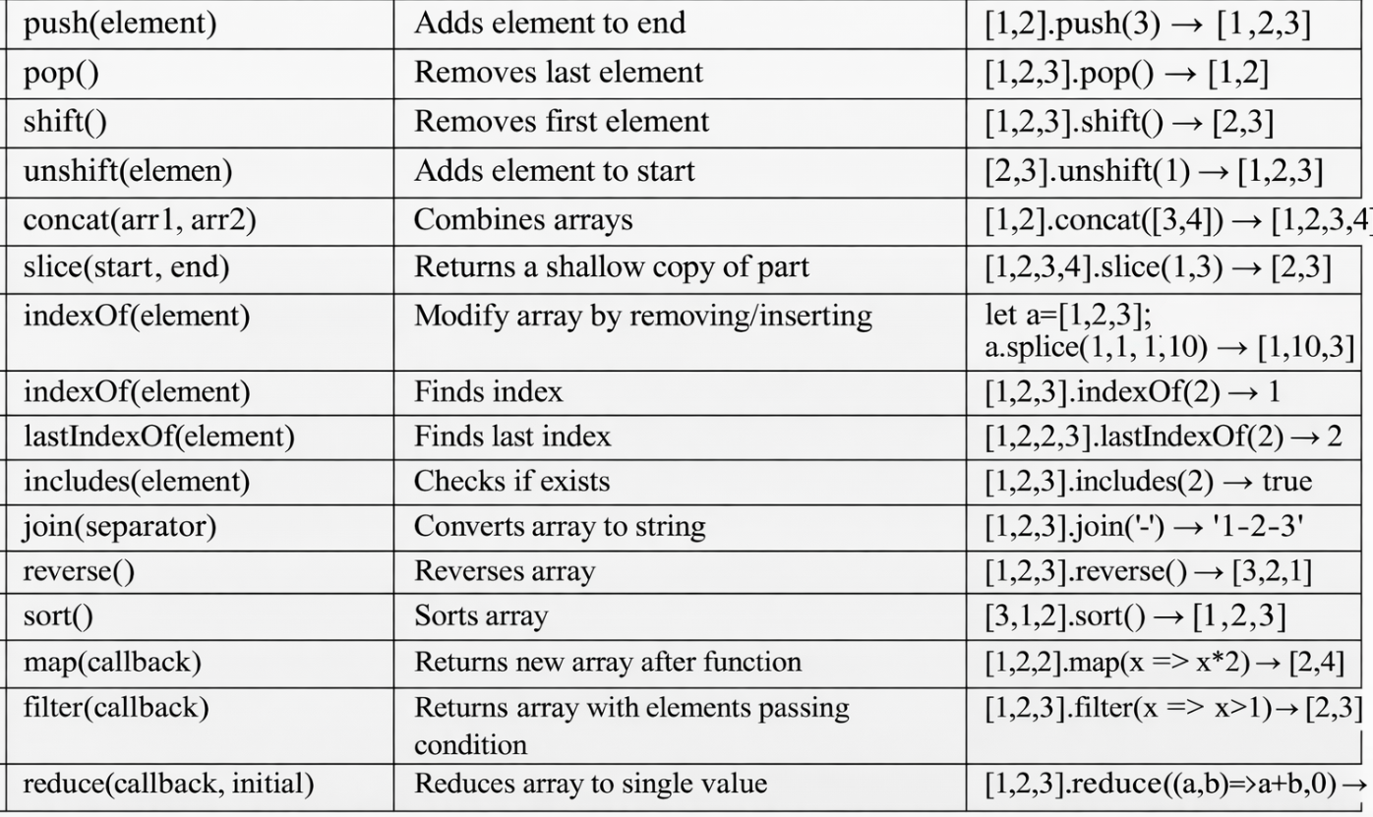

Objects
1. What is an Object?
Objects are collections of key-value pairs, where keys are strings (or symbols) and values can be any data type.
Objects help model real-world entities
Example:
const student = { name: "Hari", age: 22, course: "FrontEnd Dev" };
2. Creating Objects
- Using object literal: const obj = { key: value };
- Using new Object(): const obj = new Object();
3. Accessing Properties
- Dot notation: student.name
Object Methods
- Functions defined inside objects are methods.
Example: const car = {
brand: "Tesla",
start: function () {
return this.brand + " started";
} };

6. Built-in Object Methods
- Object.keys(obj) → returns keys as array
- Object.values(obj) → returns values as array
- Object.entries(obj) → returns key-value pairs as array
- Object.assign(target, source) → copies properties
- Object.freeze(obj) → prevents modifications
- Object.seal(obj) → allows changes but not additions/removals
- Object.isFrozen(obj) → Checks if object is frozen (no add/remove/update).
- Object.isSealed(obj) → Checks if object is sealed (no add/remove, but update allowed).
- Object.defineProperty(obj, key, descriptor) → Fine-grained control over properties.

WHAT IS PROTOTYPE?
In JavaScript, every object has a hidden link called prototype.
That prototype is simply another object from which it can borrow properties and methods.
To access that internal object we have __proto__ and Object.getPrototypeOf(objectReference).

What is Prototype Chaining?
When JavaScript doesn’t find a property in the current object, it:
- Looks in its prototype
- Then prototype’s prototype
- Continues until null
This chain is called prototype chaining.

What is prompt()?
prompt() is used to take input from the user.
What does prompt() return?
ALWAYS returns a string
If user clicks Cancel, it returns null

Example :
let age = prompt("Enter your age");
console.log(age);
console.log(typeof age);
Output:
"25"
String

Asynchronous JavaScript
What is Asynchronous JavaScript?
JavaScript normally runs line by line (synchronous).
Asynchronous JS allows:
- Some tasks to run in background
- Main code continues execution
Async JavaScript lets long tasks run without blocking the main program.

Example :
You order food in a restaurant:
- You don’t stand idle near the kitchen
- You sit, talk, use phone
- Waiter brings food when ready
Cooking = async task

Why We Need Asynchronous JavaScript
If JS was only synchronous:
UI would freeze
Browser would hang
Bad user experience

Example :
Imagine:
- Fetching data from server (5 seconds)
- If JS waits → page freezes for 5 seconds
Async JS prevents this.

Methods to Handle Async Operations
- Callbacks
- Promises
What is a Callback?
A callback is: A function passed as an argument to another function, executed later.
Example :
You give your number to a friend:
“Call me after you reach home”
That call = callback
Example :
function fetchData(callback) {
setTimeout(() => {
callback("Data received");
}, 2000);
}
fetchData(function (message) {
console.log(message);
});
Output :
Data received
WHAT IS PROMISE ?
A promise in Javascript is an Object which represents the fulfilled or rejected state of the Asynchronous Operation.
A promise will have three states :
- Pending
- Fulfilled
- Rejected

Example :
You order from Amazon:
- Ordered → Pending
- Delivered → Fulfilled
- Cancelled → Rejected
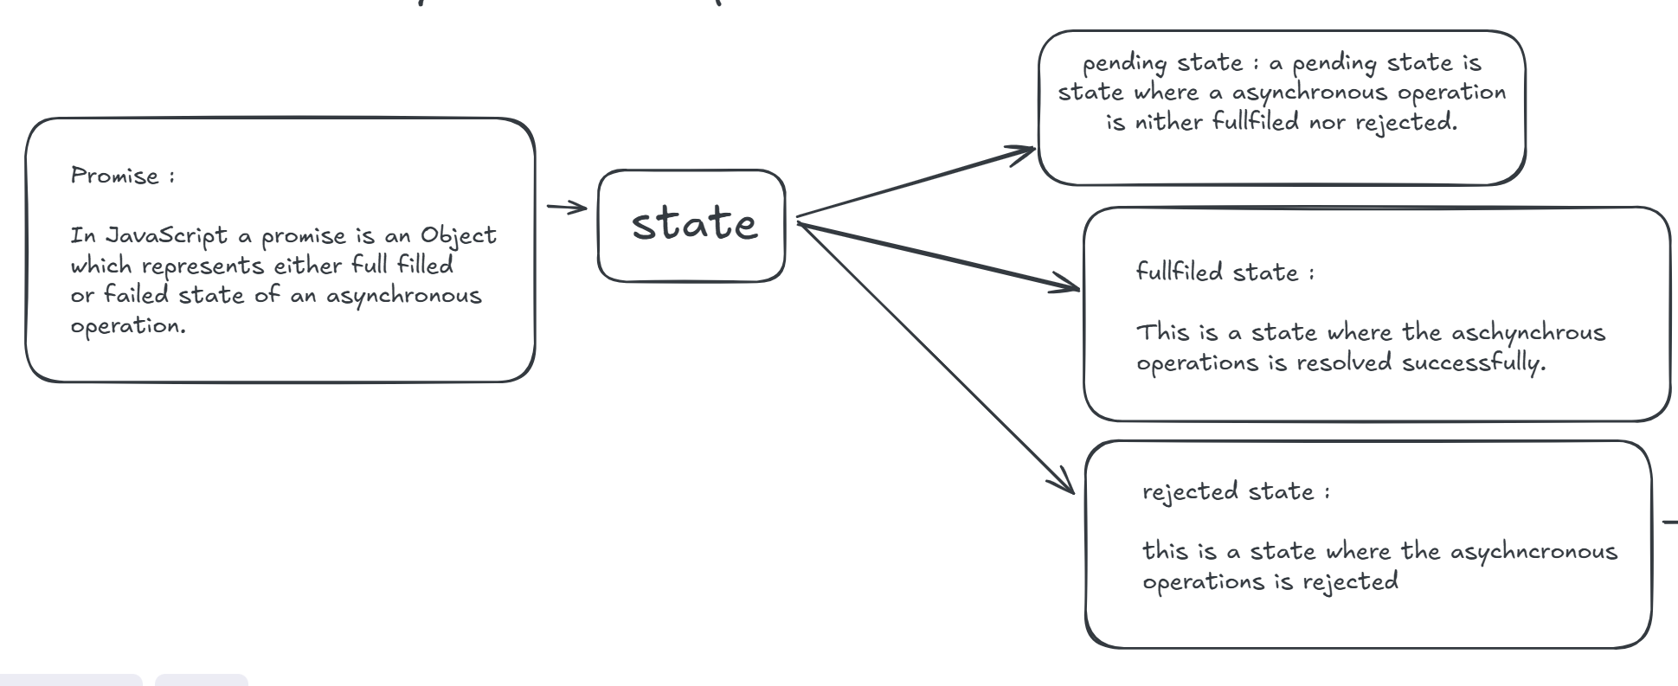
Promise Creation :
let a = new Promise( (resolve, reject)=>{ // handeling async operations } )
new -> keyword
Promise() -> it is constructor which accepts a callback function
Resolve -> it is function which is used when the promise is fulfilled.
Reject -> it is function which is used when the promise is rejected
Example :
let promise = new Promise((resolve, reject) => {
let success = true;

if (success) {
resolve("Order delivered");
} else {
reject("Order failed");
}
});

To Handle both fulfilled and rejected state we have methods :
- then() : used to handle the fulfilled state
- catch() : used to handle the rejected state
- finally() : it is used to run common code that must execute after a promise finishes, regardless of success or failure.
Example :
let respose = false;
// ? creation of a promise.

let promise = new Promise((resolve, reject) => {
if (respose == true) {
resolve("The reponse is working properly...!");
} else {
reject("The response is not working propely...!!");
}
});
promise
.then((value) => {
console.log(value);
})
.catch((value) => {
console.log(value);
})
.finally(() => {
console.log("Thank you for the response");
});
console.log(promise);

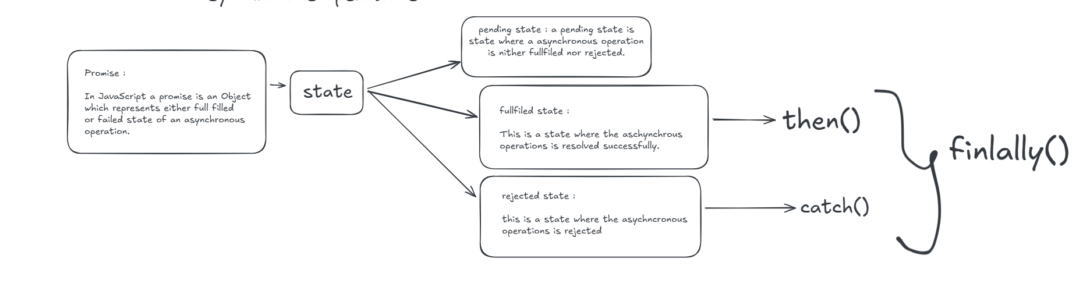

Document Object Model
What is the DOM?
DOM stands for Document Object Model. It is a programming interface that allows us to create, change, or remove elements from the document. We can also add events to these elements to make our page more dynamic.
Why DOM?
• HTML is used to structure the web pages and JavaScript is used to add functionality or behaviour to our web pages.
• When HTML file is loaded into the browser JavaScript cannot understand the HTML document directly.
• So, JavaScript interprets and interacts with the DOM, which is created by the browser based on the HTML document.
• DOM is basically of the same as HTML document but in a tree-like structure composed of objects.
• JavaScript can’t understand tags (<h1></h1>) in HTML document but can understand object h1 in DOM.
• DOM acts as a bridge/interface between JavaScript and HTML
The DOM views an HTML document as a tree of nodes. A node represents an HTML element.

DOM visualization :

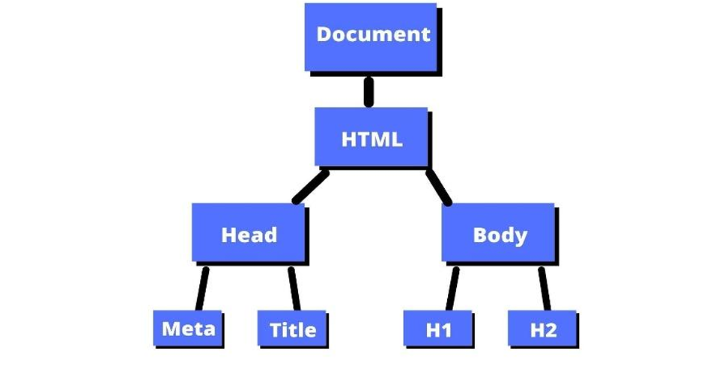
We can access these elements in the document and make changes to them using JavaScript.
DOM Accessing Methods –
-document.getElementById("id") → Selects element by id.
- document.getElementsByClassName("class") → Returns HTMLCollection of elements with given class.
- document.getElementsByTagName("tag") → Returns HTMLCollection of elements with given tag name.
- document.querySelector("selector") → Returns first element matching CSS selector.
- document.querySelectorAll("selector") → Returns NodeList of all elements matching selector.

What is an HTMLCollection?
• An HTMLCollection is a list of DOM elements that match certain criteria. For example, they may have the same tag name or class. Or they may be related in a specific context, like children of a particular element.

What is a NodeList?
• Like the name suggests, a NodeList is a list of nodes. A node is any individual element in the DOM tree. This could be elements, attributes, texts, comments, and so on.

JSON:
JavaScript Object Notation (JSON) is a standard text-based format for representing structured data based on JavaScript object syntax. It is commonly used for transmitting data in web applications (e.g., sending some data from the server to the client, so it can be displayed on a web page, or vice versa).

JSON is a text-based data format following JavaScript object syntax. It represents structured data as a string, which is useful when you want to transmit data across a network. Even though it closely resembles JavaScript object literal syntax, it can be used independently from JavaScript. Many programming environments feature the ability to read (parse) and generate JSON. In JavaScript, the methods for parsing and generating JSON are provided by the JSON object.

JSON syntax restrictions
As mentioned earlier, any JSON is a valid JavaScript literal (object, array, number, etc.). The converse is not true, though—not all JavaScript object literals are valid JSON.
• JSON can only contain serializable data types. This means:
o For primitives, JSON can contain string literals, number literals, true, false, and null. Notably, it cannot contain undefined, NaN, or Infinity.
o For non-primitives, JSON can contain object literals and arrays, but not functions or any other object types, such as Date, Set, and Map. The objects and arrays inside JSON need to further contain valid JSON data types.
• Strings must be enclosed in double quotes, not single quotes.
• Numbers must be written in decimal notation.
• Each property of an object must be in the form of "key": value. Property names must be string literals enclosed in double quotes. Special JavaScript syntax, such as methods, is not allowed because methods are functions, and functions are not valid JSON data types.
• Objects and arrays cannot contain trailing commas.
• Comments are not allowed in JSON.

JSON.stringify():
The JSON.stringify() static method converts a JavaScript value to a JSON string
Syntax: JSON.stringify(value) let jsonobj = JSON.stringify({x: 5, y: 6 });
console.log(jsonobj);

JSON.parse():
The JSON.parse() static method parses a JSON string, constructing the JavaScript value or object described by the string.
Syntax: JSON.parse(text) const json = '{"result":true, "count":42}';
const obj = JSON.parse(json);
console.log(obj);
Async Functions with async/await
Async/Await is a feature that allows you to write asynchronous code in a more synchronous, readable way.
• async is a keyword that is used to declare a function as asynchronous.
• await is a keyword that is used inside an async function to pause the execution of the function until a promise is resolved.

Example :
async function getData() {
const response = await fetch('https://jsonplaceholder.typicode.com/posts/1');
const data = await response.json();
console.log(data);
}
getData();

In this example,
• the getData function is declared as an asynchronous function using the async keyword.
• Inside the asynchronous function, we use the await keyword to wait for the fetch function to complete and retrieve some data from an API.
• Once the data is retrieved, we use await again to wait and parse the retrieved data as JSON.
• And then finally, we log the data to the console.

"Aync/Await" is a powerful tool for handling asynchronous operations. It allows for more readable and maintainable code by eliminating the need for callbacks and providing a more intuitive way to handle asynchronous operations.

Using the "async" keyword before a function definition and the "await" keyword before an asynchronous operation makes the code look more like synchronous code, making it easier to understand.

Fetch():

The Fetch API is a built-in JavaScript feature that allows you to make network requests, such as fetching data from a server. It is a modern alternative to the older XMLHttpRequest API and is designed to be easier and more powerful.

Here is an example of how to use the Fetch API to fetch data from a server:
fetch('https://some-api.com/data')
.then(response => response.json())
.then(data => { console.log(data); })
.catch(error => { console.error('Error:', error);
}); • The fetch() method is used to make a request to the server located at "https://some-api.com/data". The returned value is a promise that will be fulfilled with the server's response.
• The first .then() method is called to consume the promise and extract JSON data from the response.
• The next then() method is called to log the extracted data to the console.
• If any errors occur, they will be caught in the catch() method and logged to the console.

Destructuring:

The destructuring syntax is a JavaScript syntax that makes it possible to unpack values from arrays, or properties from objects, into distinct variables. It can be used in locations that receive data (such as the left-hand side of an assignment or anywhere that creates new identifier bindings).

This is a JavaScript expression that was introduced in ECMAScript 2015/16. In this article, you will learn how to destructure values in an array, properties in an object, and other uses of destructuring.

Destructuring in arrays:

Destructuring makes it easier to access the values of an array.
For example,
If you want to access values in an array without destructuring,
const array = ["deer","greet","heyy"];
const arr = array[0];
const arr1 = array[1];
console.log(arr); //deer
console.log(arr1); //greet
In this example, you assigned the values by using their index. But with destructuring, this is how it will be.
const array = ["deer","greet","heyy"];
const [arr,arr1,arr2] = array;
console.log(arr); //deer
console.log(arr1); //greet
So you could assign the values of the array variable to the new variables all at the same time.

Destructuring in Objects :

With object destructuring, you can retrieve property values from an object.
Objects take a different syntax from arrays when assigning values to variables.
To assign values without destructuring would be:
const obj = { word: "dataTypes", num: 0001, bool: true, bigInt: 2.99999999}; //example of the object

//To access the object property
const words = obj.word;
const boolean = obj.bool;
console.log(words) //dataTypes
console.log(boolean) //true

This is how to assign values to objects using destructuring.
const obj = { word: "dataTypes", num: 0001, bool: true, bigInt: 2.99999999}; //example of the object //To access the object property
const { word, bool } = obj;
console.log(word) //dataTypes
console.log(bool) //true
This makes value assignments easier.
Note: The order does not matter in objects, and you should use the same name.
Rest parameter & Spread operator

The spread operator (…) and the rest parameter (…) in JavaScript are both denoted by three dots (…), but they serve different purposes.

The browser doesn’t specifically “understand” whether it’s a spread operator or a rest parameter. Instead, it follows the JavaScript language specification, which defines how the three dots are interpreted based on the context in which they appear in the code. The browser executes it accordingly if the code adheres to the language rules.

Rest operator(`…`):
The rest operator (…) is used in function parameters to collect all remaining arguments into an array.
1. The rest parameter syntax allows a function to accept an indefinite number of arguments as an array.
2. It collects all remaining arguments into an array, which can be accessed from inside the function. 3. The rest of the parameters (…restArguments) must be the last parameter in a function declaration.

Spread Operator (`…`):
The spread operator (…) is used to expand or spread elements from an iterable (such as an array, string, or object) into individual elements.
The spread operator divides an array or object into separate elements or properties. The spread operator is mostly used if you want to duplicate the content of an array or combine or combine multiple arrays/objects together.
Uses of Spread operator:
1. Copying Arrays and Objects
2. Combining Arrays and Objects
3. Passing Arguments to Functions
What is a Module?
JavaScript modules are a way to organize and structure code. They allow developers to break their code into smaller, reusable pieces. You can think about them as smaller pieces of code that you can import and export between different parts of an application.
Modules are a powerful feature in JavaScript that allow developers to organize and structure their code for improved readability and reusability. They also help you avoid naming conflicts.
By breaking down large codebases into smaller, manageable modules, developers can write more efficient and maintainable code.

Types of File Exports in JavaScript
1.Default Exports :
Perform a default export in a JavaScript file like this:
function getAllUser(): export default getAllUser
Note: You can only use one default export in a JavaScript file.
You can also export before the declaration,
like this: export default function getAllUser():
2.Named Exports:
Named exports allow you to share multiple modules from a file, unlike default exports which can only have one in a file.
You won't need to use the "default" syntax when using named exports.
Named exports also need to be enclosed in curly brackets if you are exporting more than one module.
Here's an example:
const name = "Hari"
export name;
How to Import Modules?
How to Import a Single Default Export?
Here is how to import a default export:
import getAllUser from "getuser.js";
How to Import a Single Named Export?
That's all – you can then proceed to use the getAllUser function anywhere in that file.
Here is how to import a single named export.
import {name} from "username.js"
How to Import Multiple Named Exports?
Here is how to export multiple named exports.
import {name, sayHello} from 'user.js'
How to Rename Imports?
You can also rename exports before using them in a JavaScript file.
Here's how to do it:
import {userName as name, greet as sayHello} from 'user.js'
It basically imports the name and 1sayHello1 module and renames them,
so you can only make reference to "userName" and "greet" in this current module.
Object Oriented Programming :
Class: Classes are a template for creating objects. They encapsulate data with code to work on that data.
Or
In JavaScript, a class serves as a blueprint for creating objects with shared properties and methods. Introduced in ES6, classes provide a more structured and object-oriented way to organize code compared to the older prototype-based approach.
Class body
The body of a class is the part that is in curly braces {}.
This is where you define class members, such as methods or constructor.
The constructor method is a special method for creating and initializing an object created with a class.
There can only be one special method with the name "constructor" in a class —
a Syntax Error is thrown if the class contains more than one occurrence of a constructor method.
class Rectangle {
constructor(height, width) {
this.height = height;
this.width = width;
} }
const square = new Rectangle(10, 10);

TypeScript :
TypeScript is a syntactic super set of JavaScript which finds the bug in the code at compile time. It is a static type language which is developing Purpose only.

Type Inference :
typescript automatically detecting the type of the data while runtime
we should use this type inference for only primitive data types
Type annotation :
by our self we will be specifying the data type

